單神經元感知機系統設計
Single Neuron/Perceptron

陳慶瀚
MIAT實驗室/國立中央大學資工系
2023年10月31日

- 生物與人工的神經元模型

The most basic element of the human brain is a specific type of cell – neuron. The human brain contains approximately 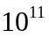 neurons each having the ability to receive, process and transmit electrochemical signals. A simplified view of a neuron is shown in the diagram below.
Cell body (soma)
Nucleus
Axon
Synapses
Dendrite
Fig.1 Biological neuron

A neuron contains a cell body (soma) and several branches that accept input information to the cell (dendrites), or transmit information out of the cell (axons). Interaction among the neurons takes place at the connection points – synapses. To model the brain we need to model a neuron. Each neuron performs a simple computation. It receives signals from its input links and it uses these values to compute the output for the neuron. This value is passed to other neurons via its output links. The input value received of a neuron is calculated by summing the weighted input values from its input links. That is
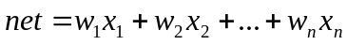
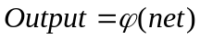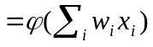
where 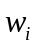 denotes the strength of connection between artificial neuron and the neuron under consideration, 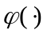 is an activation function. A graphical representation of the simple structure of an artificial neuron is presented as below.
Fig.2 Artificial neuron structure
Σ
Output
w₁
w₂
w_{n}
x₁
x₂
x_{n}

A neuron is connected to other neurons via its input and output links. Each incoming neuron has an activation value and each connection has a weight associated with it. The neuron sums the incoming weighted values and this value is input to an activation function. The output of the activation function is the output from the neuron. Typical activation functions are shown in Table 1. Sigmoid, tan hyperbolic (tanh) and “Unnamed” functions are grouped under soft nonlinearity, whereas step function (i.e. Hard Limited function) is under hard type nonlinearity. These functions are presented graphically in fig.2 for convenience.

Table 1. Activation functions commonly used in artificial neuron structure.
Name | Activation function
Hard Limited | 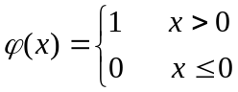
Tanh | 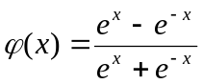
Sigmoid | 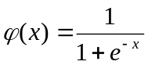
Unnamed | 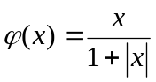

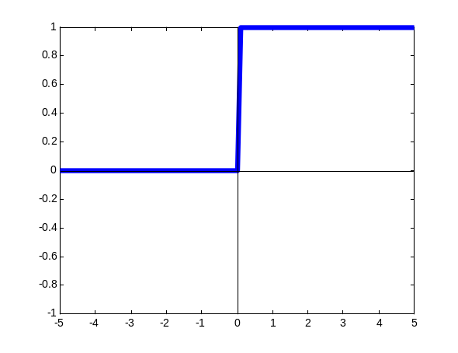  (a) Hard Limited | 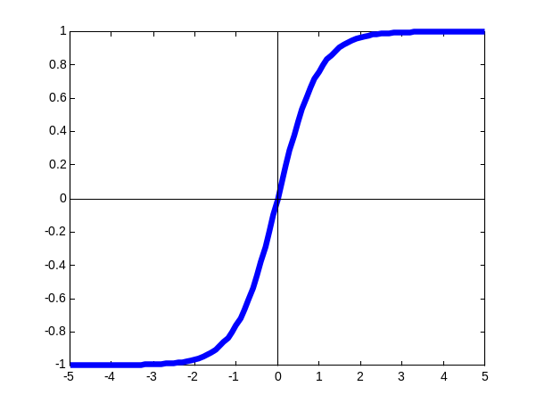  (b) Tanh
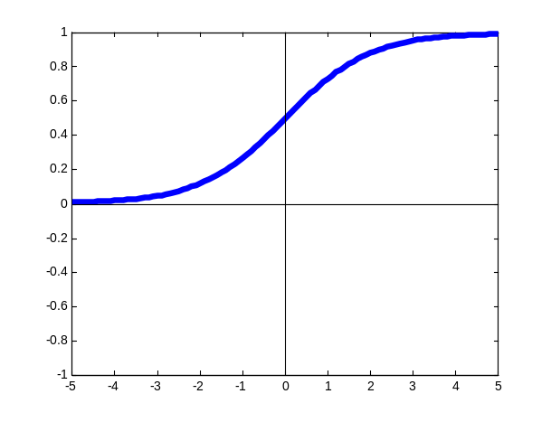  (c) Sigmoid | 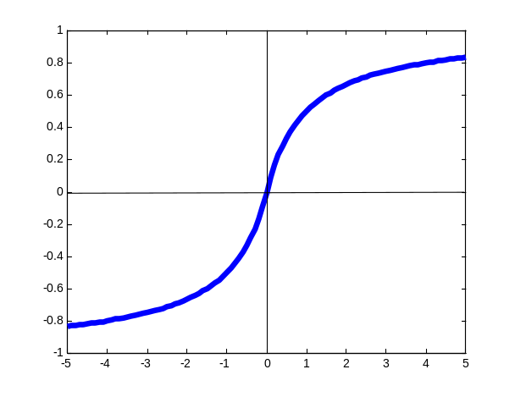  (d) Unnamed

Fig.2 Common nonlinear functions used for synaptic inhibition. (a) Hard Limited , (b) Tanh, (c) Sigmoid, (d) Unnamed.

A nonlinear activation function is generally used because the nonlinearity gives the network far more computational versatility. For convenience let us study the case where the input vector and the weight are both two-dimensional: 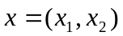, 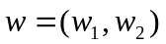. Then we spell out the activation function thus:

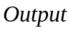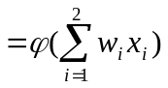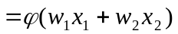

- 感知機(Perceptron)

神經元是類神經網路組成的基本的單位，雖然Minsky以專書討論缺乏隱藏層的類神經網路無法解決互斥或(exclusive OR, XOR)的問題。但是，一些較簡單的問題仍然可以應用單一神經元解決問題。其優點為架構簡單，無論學習或回想的時間都較短，缺點則是無法解決互斥或的問題以及精確性較差。

單神經元的模型如圖3。
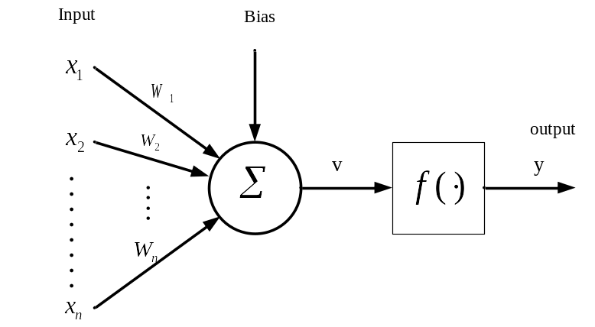
圖3、單神經元模型

其中
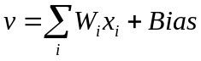
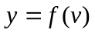
其中，為網路的輸入，y為網路的輸出，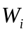為網路的連接加權值， Bias為偏移量，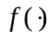採用sigmoid轉換函數，亦即
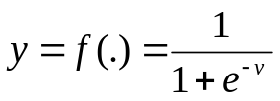

一個具有學習能力的單神經元模型通常稱為感知機(perceptron), 感知機學習目的在於針對一組觀測的輸入-輸出資料，找到最佳的神經元參數Bias和連結權值W_{i}。一個最常用來訓練神經元的演算法稱為最陡坡降(Gradient Steepest Descent)法，。

假設輸入的特徵向量為X={x1,x2,x3,x4}，連結權值W_{i}初始設定值{ w₁、w₂、w₃、w₄}為四個0~1之間的浮點數， t是觀測輸出，y是感知機的推論輸出，η(eta)是學習速率，θ(theta)則是bias。我們藉以下兩個公式進行迭代修正W_{i}以及θ：
Δw = w +η(t-y)x
θ = θ +η(t-y)
迭代修正的目標以期最小化感知機的推論輸出和觀測輸出的差異量。
這兩個公式的pseudo code如下：
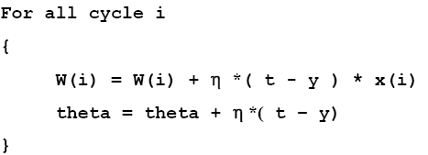

3、參考程式碼

//感知機轉移函數
float ActivationFunction(float net)
{
return 1.0/(1.0+exp(-net));
}

//感知機推論輸出
float Stimulate(float *x)
{
float net=0;
for(int i=0;i<nb_in;i++)net+=x[i]*weight[i];
net+=bias;
return ActivationFunction(net);
}

// 感知機學習演算法
void Learning(float *x, float target)
{
count++;
float net=0;
for(int i=0;i<nb_in;i++)net+=x[i]*weight[i];
net+=bias;
float y=ActivationFunction(net);
for(int i=0;i<nb_in;i++)
weight[i] = weight[i] + eta*(target-y)* x[i];
bias = bias + eta*(target-y);
}
// 感知機分類性能測試
float Neuron::Testing(float *x, float target)
{
float y=Stimulate(x);
return sqrt((y-target)*(y-target));
}

4、作業
請以MIAT系統設計方法論完成一個2-input感知機神經元設計:
- 以IDEF0設計感知機系統的階層式模組化架構
- 以Grafcet設計每一個模組的離散事件模型
- 以方法論合成C code
- 結合底層API函式呼叫，完成軟體驗證
- 基於此一程式，進行下列實驗：
連結權值w1,w2初值分別設為為 0, 0.4，bias( θ) 初值 = 0.3，請使用感知機學習演算法來推演 logical AND function的學習過程假設學習目標是AND函式如下：
x1 | x2 | t
0 | 0 | 0
0 | 1 | 0
1 | 0 | 0
1 | 1 | 1
輸出感知機學習過程，如下
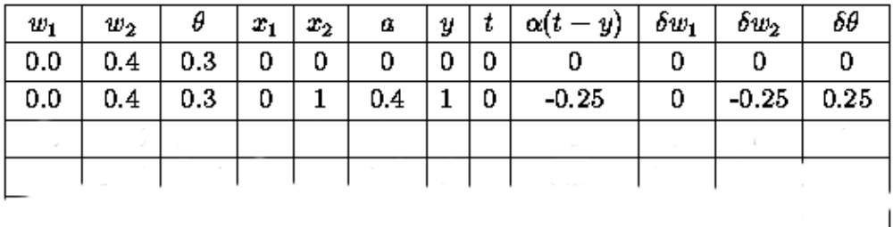
至少計算50次迭代，每完成一次迭代，就計算感知機的推論誤差(4筆推論輸出誤差和)：
E = sqrt((y-t).(y-t))
將50次誤差繪製成曲線，可得知感知機的學習收斂特性。
可以改變w1,w2, bias(θ)初值，重複相同實驗。

請於11月14日前繳交Word檔報告和程式碼和執行結果畫面

